Q1. Explain the difference between frontend, backend, and full-stack development with suitable real-world examples.
Frontend Development
- Definition: The frontend is the part of a website or web app that users see and interact with directly.
- Technologies Used: HTML (structure), CSS (styling), and JavaScript (interactivity).
- Main Focus: User Interface (UI) and User Experience (UX).
- Example:
  - When you open Amazon, the product listings, buttons, and navigation menus you see are created by frontend developers.
  - Frameworks/Libraries: React.js, Angular, Vue.js.

Backend Development
- Definition: The backend is the server-side part of a web application that handles logic, database operations, and user authentication.
- Technologies Used: Node.js, Python (Django/Flask), PHP, Java (Spring), etc.
- Main Focus: Database management, API creation, and server logic.
- Example:
  - When you log in to your Instagram account, the backend checks your username and password, fetches your data from the database, and returns it securely.

Full-Stack Development
- Definition: Full-stack developers work on both frontend and backend parts of a project.
- Technologies Used: A mix of frontend (HTML, CSS, JS) and backend (Node.js, MongoDB, etc.).
- Example:
  - A MERN Stack Developer (MongoDB, Express, React, Node) can build a complete app like a task manager—from login page (frontend) to storing tasks (backend).
Q2. Create a simple diagram showing how the client-server model works in web architecture.
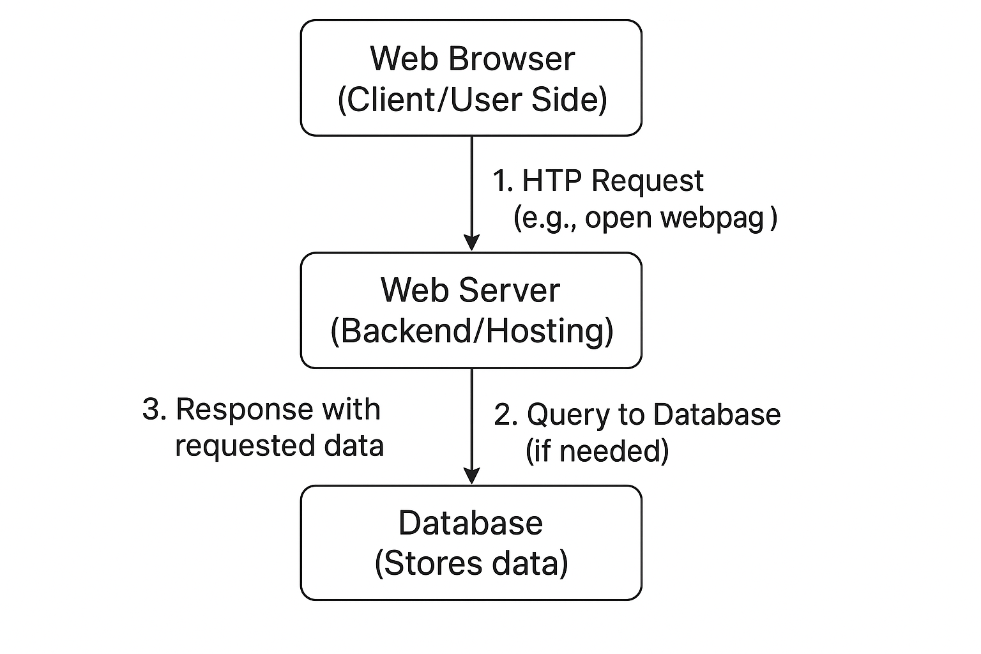
Q3. Describe how a browser requests and displays a web page from a web server.
Steps:
- User Request:
The user types a URL (like www.google.com) into the browser.
- DNS Resolution:
The browser contacts a DNS server to convert the domain name into an IP address.
- HTTP/HTTPS Request:
The browser sends a request to the web server using HTTP or HTTPS protocol.
- Server Processing:
The server locates the requested file (like index.html) or executes backend logic if it’s a dynamic page.
- Response Sent:
The server sends an HTTP response containing HTML, CSS, JS, and other resources.
- Rendering:
The browser’s rendering engine parses the HTML, applies CSS styles, and executes JavaScript.
- Display:
The web page is displayed to the user.

Q4. Identify and list the tools required to set up a web development environment. Explain the purpose of each.
Tool | Purpose
VS Code / Sublime Text | Code editor for writing HTML, CSS, JS
Web Browser (Chrome, Firefox) | For testing and debugging webpages
Node.js | To run JavaScript on the server and manage packages
Git & GitHub | Version control and code collaboration
XAMPP / WAMP / Live Server | Local web servers for running and testing websites
Browser DevTools | Inspect elements, debug code, and monitor performance

Q5. Explain what a web server is and give examples of commonly used servers.
Definition:
A web server is a software or hardware system that delivers web pages to users upon request using HTTP or HTTPS protocols.
Examples:
- Apache HTTP Server – Open-source and widely used.
- Nginx – High performance, used for load balancing.
- Microsoft IIS – Integrated with Windows Server.
- LiteSpeed – Known for speed and efficiency.
- Node.js (Express) – Used in JavaScript-based servers.
Q6. Define the roles of a frontend developer, backend developer, and database administrator in a project.
Role | Responsibilities
Frontend Developer | Designs and implements the UI using HTML, CSS, and JavaScript. Ensures responsiveness and user experience.
Backend Developer | Manages server logic, APIs, and database connections. Handles authentication, data processing, and performance.
Database Administrator (DBA) | Designs, maintains, and secures databases. Handles backups, optimization, and query performance.

Q7. Install VS Code and configure it for HTML, CSS, and JavaScript development.
Steps:
- Download and install Visual Studio Code from https://code.visualstudio.com.
- Install extensions:
  - Live Server (for real-time preview)
  - Prettier (for code formatting)
  - HTML CSS Support
- Create a folder and open it in VS Code.
- Make files: index.html, style.css, and script.js.
- Right-click on index.html → Open with Live Server to view your site in a browser.
📸 Take a screenshot of your workspace showing VS Code with an HTML file open.

Q8. Explain the difference between static and dynamic websites. Provide an example of each.
Type | Description | Example
Static Website | Displays fixed content that doesn’t change unless manually updated. No database. | A portfolio website (e.g., https://exampleportfolio.com)
Dynamic Website | Content changes dynamically based on user input or database data. | Social media platforms like Facebook or Instagram

Q9. Research and list five web browsers. Explain how rendering engines differ between them.
Browser | Rendering Engine | Description
Google Chrome | Blink | Fast, open-source engine optimized for performance
Mozilla Firefox | Gecko | Known for customization and standards compliance
Apple Safari | WebKit | Efficient for macOS and iOS platforms
Microsoft Edge | Blink | Modern engine shared with Chrome
Opera | Blink | Built-in VPN and ad-block features
Difference:
Rendering engines interpret HTML, CSS, and JS differently, which can cause slight variations in how websites appear across browsers.

Q10. Draw a labeled diagram showing the basic web architecture flow — client, server, database, and APIs.
–––

